Revista de Ciencias Económicas 43-N°2: enero-junio 2024 / e51726 / ISSN: 0252-9521 / ISSN: 2215-3489  
Abre 1 de enero y cierra 30 de junio de 2024  
<https://revistas.ucr.ac.cr/index.php/economicas>

Impact of the Inflation Reduction Act on the United States stock market, the clean energy sector and the automotive industry, an event study[1]

J. CAMILO SALDARRIAGA[2];

To Víctor Barquero and Diego Benavides, two young and passionate economists who are no longer with us.

Recibido: Aprobado:

User

Abstract

The present article evaluates the impact of the Inflation Reduction Act (IRA) approval on the United States stock market, specifically on the energy sector and automotive industry. The article applies the event study methodology by estimating a Mean-adjusted return model and a Market return model with dummy variables for the events. The model is estimated around four events related to the bill’s approval. The article concludes that the stock market in general did not experience abnormal returns in the event windows related to the bill’s approval. However, the energy sector as a whole, the renewable energy segment, the oil and gas industry, and the automobiles industry presented abnormal returns around key events of the approval process. In the specific case of the electric vehicle segment, the study does not find conclusive evidence of abnormal returns around the events.

**KEYWORDS:** Financial Markets, Financial Economics, Event Study, Abnormal Returns, Inflation Reduction Act.

**ACADEMIC RANK**

**JEL:** G1, G10, G180.

Impacto de la Ley de Reducción de la Inflación en el mercado de valores de Estados Unidos, el sector de energía limpia y la industria automotriz, un estudio de eventos

Resumen

El presente artículo evalúa el impacto de la aprobación de la Ley de Reducción de la Inflación (IRA en inglés) en el mercado de valores de los Estados Unidos, específicamente en el sector energético y la industria automotriz. El artículo aplica la metodología de estudio de eventos mediante la estimación de un modelo de retorno ajustado por la media y un modelo de retorno del mercado con variables ficticias para los eventos. El modelo se estima en torno a cuatro eventos relacionados con la aprobación de la ley. El artículo concluye que el mercado de valores en general no experimentó rendimientos anormales en las ventanas de eventos relacionadas con la aprobación de la ley. Sin embargo, el sector energético en su conjunto, el segmento de energías renovables, la industria de petróleo y gas, y la industria automotriz presentaron rendimientos anormales alrededor de los eventos clave del proceso de aprobación. En el caso específico del segmento de vehículos eléctricos, el estudio no encuentra evidencia concluyente de rendimientos anormales alrededor de los eventos.

**PALABRAS CLAVE:** Mercados Financieros, Economía Financiera, Estudio de Eventos, Retornos Anormales, Ley de Reducción de la Inflación.

**RANGO ACADÉMICO**

**JEL:** G1, G10, G180.

**1. INTRODUCTION:**

On September 27, 2021, the US administration presented the Build Back Better Act, a bill containing a broad set of subsidies for the green energy sector, the automotive industry, and the manufacturing sector in the United States. Almost one year later and after a long negotiation process, the bill was substantially transformed by the Senate and was finally approved with the name of Inflation Reduction Act (IRA). The approved bill included massive stimulus to accelerate investments in renewable energy and the production of electric vehicles in the United States.

According to the Penn-Wharton Budget Model (Huntley Ricco & Arnon 2022), the bill contains a total provision of $384.9 billion for climate change and renewable energy, from which 63.7% is dedicated to renewable energies and 5.9% is dedicated to stimulating the electric vehicles adoption and production in the United States, 12.1% goes to the manufacturing industry, 11.8% goes to environmental policies, 5.3% to agriculture and 1.2% to water investments (Badlam et al. 2022). The bill is not only relevant for its financial volume but also for the magnitude of its impact on the United States CO2 emissions. It is estimated that the IRA’s impact on the United States emissions will be significant, as it will“cut annual emissions in 2030 by an additional 1 billion metric tons” (Jenkins, J.D. et al. 2022).

The present study uses the standard event study methodology to evaluate the impact of the bill’s approval on the United States stock market. In particular, it analyses the impact on the energy sector and the automotive industry. For that, I evaluate five different benchmark indexes: the NASDAQ Clean Energy Edge Index, the S&P 500 Automobiles Industry Index, the S&P Kensho Electric Vehicles Index, the Dow Jones U.S. Oil & Gas Index, and the S&P500 Energy Index.

The event study methodology is applied by estimating a Mean-adjusted return model and a Market return model with dummy variables for the key events. The model is estimated using three days and five days windows around four key events: the presentation of the bill to Congress, the announcement of Senator’s Manchin opposition to the bill, the agreement with Senator Manchin which was key to the approval, and the vote of the bill by the Senate. Normally, the use of event study methodologies to evaluate the impact of legislation approval has particular challenges, as the results of legislative votes are known in advance given the number of representatives from each party. For this study, I took advantage of several particularities in the IRA approval process that allowed me to apply successfully the event study methodology.

**2 Literature Review: Event study methodology and its application to legislative processes**

**2.1 The event study methodology**

The event study methodology is well-established in the field of financial economics. There is plenty of literature that discusses and replicates the methodology, beginning in the late sixties until today. In their seminal article Fama Fisher, Jensen, and Roll (1969) evaluated how stock prices incorporate the information of stock splits. By doing so, they settled the basis of what we know today as event studies. To evaluate the price reaction to stock split, they estimate the regression

Where is the stock's return, and is the market's return.

It is important to highlight that, Fama Fisher, Jensen, and Roll do not include the period of the analyzed event in the estimation. They estimate the parameters without the event´s period and then, with the estimated parameters, they calculate the error for the event's dates, the mean of the error is considered as the measure of the abnormal return. The authors also evaluate the different estimation methods, they conclude that even when the data is not normally distributed, OLS provides estimators that are unbiased and consistent. They also highlight the problems of the T-statistic for hypothesis testing given the non-normality of residuals.

In Brown and Warner's article (1980), the authors extend Fama Fisher, Jensen, and Roll's methodology. By using the same principle, they evaluate three different regression models for stock prices and evaluate the accuracy of each one of them. According to them, the notion of abnormal return requires a benchmark value for comparisons, which leads them to evaluate three possible benchmarks. The first model called the Mean Adjusted Return Model establishes that the expected return of an asset is given by a constant , where the abnormal return of asset i on period t corresponds simply to the difference between the observed return and the mean return .

The second model evaluated by Brown and Warner is the Market Return model in which the expected return of an asset is equal to the market return . Finally, the authors evaluate the Market and Risk Adjusted Return model in which the expected return of an asset is given by the CAPM model with

Here the abnormal return is given by

The authors select randomly 250 securities and introduce artificial abnormal returns into the historical data using monthly returns, then they evaluate the capacity of the three models to identify the abnormal returns. Surprisingly they find that the models produce similar results and that "beyond a simple, one-factor market model, there is no evidence that more complicated methodologies convey any benefit. In fact, we have presented evidence that more complicated methodologies can actually make the researcher worse off" (Brown & Warner 1980).

Dyckman, Philbrick, and Stephan (1984) replicate Brown and Warner's simulation with daily data and include 2 additional return models: Scholes-Williams and Dimson models. The article concludes that the Market Return Model is slightly better than the Mean Adjusted Return and the Market Adjusted Return models in detecting abnormal returns. The Scholes-Williams and Dimson did not improve the capacity to detect abnormal returns, which reinforces the argument in favor of simple models. Finally, the authors conclude that the capacity to detect abnormal returns of models decreases considerably when the date is unknown, and the portfolios are smaller. Dyckman, Philbrick, and Stephan also analyzed the potential problems of T-tests given the non-normality of residuals, they conclude that "nonnormality of individual-security daily-return residuals has little effect on the inferences drawn from the use of the t-test applied to portfolios" (Dyckman, Philbrick, and Stephan 1984).

In a second article, Brown and Warner evaluate again different return models using daily data and reinforce the evidence in favor of simpler return models. Additionally, the authors conclude that estimation methods different from OLS do not provide clear advantages for the return models. MacKinlay (1997) uses a market return model with the specification

to evaluate the impact of news on the market return. The author highlights the limited gains of using multifactor models for event studies and concludes that a fundamental requirement for event studies to be successful is that the event date can be identified precisely, otherwise, the methodology loses much of its statistical power.

Blinder (1998) makes a review of the evolution of event studies methodology. Blinder underlines the increasing popularity at that time for an estimation method that includes the event period on the dataset while including at the same time a dummy variable for the analyzed events. This way, the return equation will be:

where is the dummy variable equal to 1 for each event j and is the abnormal return parameter for event j. The existence or not of the abnormal return is evaluated by the significance of . One important warning of Blinder regarding this specification is that the hypothesis testing will not be very powerful statistically speaking if the signs of the effects are different. In those cases, it is better to estimate different regressions for each event.

Khotari and Warner (2006) review the evolution of event studies through time. They conclude that the core methodology has not changed substantially since Fama, Fisher, Jensen, and Roll's (1969) seminar article, however, new methodological consensus has appeared to improve estimations. For example, Khotari and Warner point out that events with long-horizon impacts have important limitations, while events with short-term impacts remain effective and statistically powerful.

**Event study methodology applied to legislative processes**

Ali and Kallapur (2001) apply the event study methodology to the bill approval process on the United States to determine the effects of the Private Securities Litigation Reform Act of 1995. They measured the price reactions of events that changed the likelihood of the approval of the law. The authors include a set of events that provided new information to markets regarding the law's approval, this included a presidential veto and its subsequent override by Congress.

Ali and Kallapur identify three particular challenges to applying the event study methodology for law approval processes: first, it is difficult to identify all the major events that affect the approval process. Second, It is necessary to identify the precise date in which that information is provided to the markets. Third, it is necessary to identify when the markets first anticipated the effects of such events. For the estimation they use the Market Return model with dummy variable for the dates of the events

The authors conclude there is evidence of negative market price reactions to events that increased the likelihood of the law's approval.

Rezaee and Pankaj (2005) apply the event study methodology to the The Sarbanes-Oxley Act approval process in 2002. Using a three-day cumulative abnormal return window the authors evaluate 12 Congressional events using the Mean Adjusted Return Model with dummy variables for the events

.

Rezaee and Pankaj found positive significant abnormal returns around the events that increased the probabilities of the law's approval.

In both cases, the authors underscore that to apply the event study methodology analyzed events must provide new information that was not previously available to the market. As I will explain later, the particular circumstances surrounding the IRA's approval generated a set of events that comply with this requirement.

**3 Data: daily data between January 2 of 2018 and December 30, 2022**

The data used for the stock indexes and the market return corresponds to the daily closing values for the period between January 2 2018 and December 30, 2022. As the IRA’s investments focus mainly on the energy sector and the automotive industry group, I will analyze those two sectors. The analysis for the energy sector is divided into two different parts: first I analyze the whole energy sector, including non-renewable and renewable energy companies. Following Bessec and 4 Fouquau (2024), I use the S&P500 Energy index and the Dow Jones U.S. Oil & Gas Index.For the automotive industry I will use the S&P 500 Automobiles Industry index. The index time series was extracted from Yahoo Finance using Python's yfinance Package (SP500-251020, 2023).

Then, I focus on the specific renewable energy segment. To measure the impact on the clean energy segment I use the NASDAQ Clean Energy Edge Index, this Index composed of 56 U.S. listed stocks, tracks the performance of companies that are ”primarily manufacturers, developers, distributors and/or installers of clean energy technologies” (NASDAQ 2024). For the final part of the energy sector analysis, I evaluate the impact on the oil and gas companies by using the Dow Jones U.S. Oil & Gas Index, which contains the main 45 U.S. companies from the oil and gas sector.

For the automotive industry, I use first the S&P 500 Automobiles Industry Index which tracks the behavior of the automotive industry as a whole in the United States (SP500-251020, 2023). Then, I use the S&P Kensho Electric Vehicles Index which contains 44 U.S.-listed companies producing electric vehicles and associated subsystems and infrastructure (S&P Globa, 2024a).

In the case of the NASDAQ Clean Energy Edge Index, the data was downloaded directly from NASDAQ’s webpage(NASDAQ, 2024). For the S&P Kensho Electric Vehicles Index, the S&P 500 Energy index, and the Dow Jones U.S. Oil & Gas Index, the data was downloaded from the S&P Global’s webpage (S&P Global, 2024a, 2024b, 2024c). Finally, for the S&P 500 Automobiles Industry index, the data was extracted from Yahoo Finance using Python’s yfinance Package (SP500-251020, 2023).

For the market return data, I used Fama and French market daily risk premium and daily risk-free return (Fama and French 2024). Fama and French calculate the market return variable using as a basis the data from the Center for Research in Security Prices (CRSP), specifically from the CRSP US Total Market Index, which represents 100% of the US equity market. However, the market index on the Fama-French library refers to the market risk premium Rm − Rriskfree, therefore, to obtain the market return I added back the risk-free rate.

The data on the risk-free rate was also obtained from Fama and French library (Fama and French 2024). The details of the construction of the Fama-French library can be found on Fama and French (2023).

Graph 1 presents the historical behavior of the variables’ returns, while Table 1 presents basic descriptive statistics of the data.

**Graph 1: Daily returns between January 2, 2018 and December 30 2022, 1 250 observations** 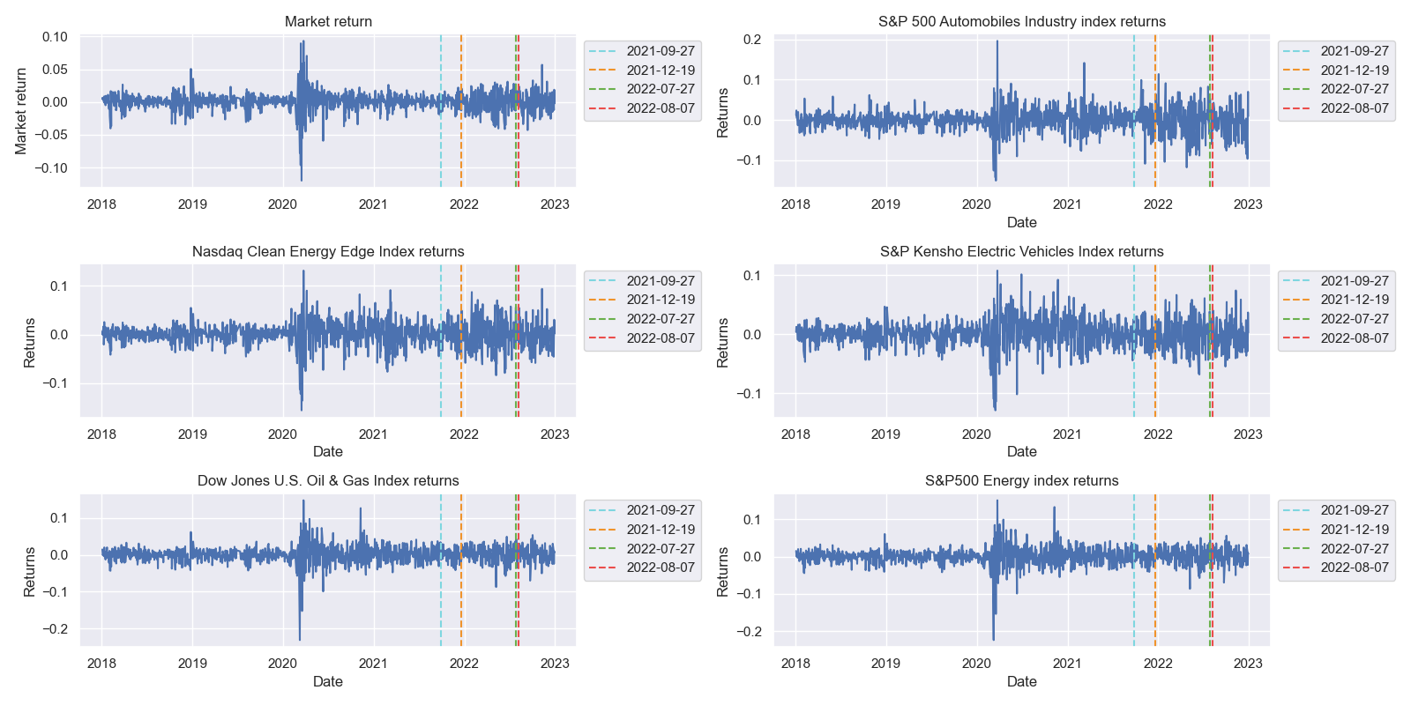

Source: Own elaboration with data from Fama & French (2023), ECO. (2023) and SP500-251020, (2023)

Note: Market return was obtained from Fama-French data library (Fama \& French 2024), which is built based on the Center for Research in Security Prices market index, which represents 100\% of the US equity market.

**Table 1: Descriptive statistics, 1 149 observations**

Source: Own elaboration with data from Fama & French (2023), ECO. (2023) and SP500-251020, (2023)

The visualization of the data shows that the 6 variables are centered around 0, this is confirmed by the summary statistics in Table 1. It is possible to observe an important increase in volatility around the pandemic. In the period that encompasses the four events, there is also an increase in volatility, this may be explained by the increases in the United States Fed Fund rates, which began in April 2022. All six indexes have very similar standard deviations and higher volatility than the market. All the variables, except for the S&P Kensho Electric Vehicles Index, present a Kurtosis considerably different from 3, especially the automotive industry index. To observe more clearly the variables’ behavior around the dates of the event, I present on Graph 2 a zoom around the analyzed events.

**Graph 2: Daily returns between July 27 2021 and September 07 2022, 256 observations** 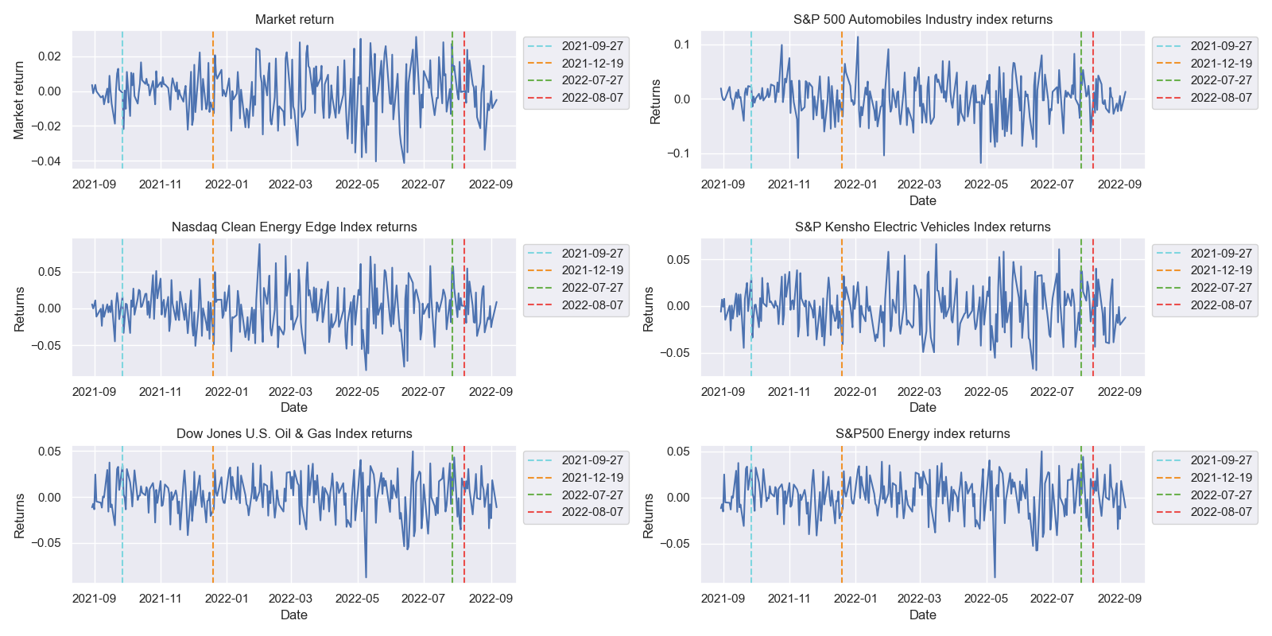

Source: Own elaboration with data from Fama & French (2023), ECO. (2023) and SP500-251020, (2023)

**Graph 3: Correlation heat-map, 1 149 observations**

Source: Own elaboration with data from Fama & French (2023), S&P Global (2024a, 2024b, 2024c), NASDAQ (2024) and SP500-251020, (2023)

Graph 3 presents the correlation heat map between the variables. The five indexes have correlation coefficients with the market greater than 0.65. The NASDAQ Clean Energy Edge Index is strongly correlated with the S&P Kensho Electric Vehicles Index, something that reflects the strong ties between both sectors. Interestingly all the correlation coefficients are positive, and the smallest value is 0.46 between the S&P500 Energy Index and the S&P 500 Automobiles Index.

To evaluate the normality of the variables, I applied the Jarque-Bera normality test. The results are presented in Table 2. As can be seen, the null hypothesis of normality is rejected for the six variables. In line with the observation of Fama, Fisher, Jensen, and Roll (1969), the returns do not follow a normal distribution.

**Table 2: Jarque-Bera normality tests, 1 149 observations**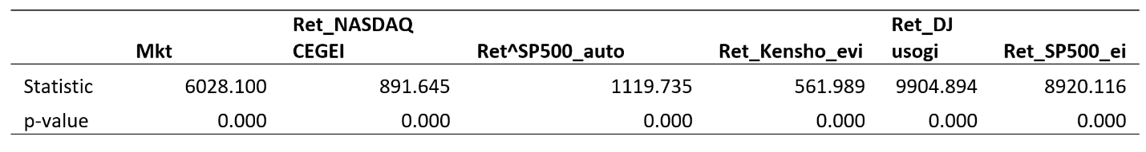

Source: Own elaboration with data from Fama \& French (2023), ECO. (2023) and SP500-251020, (2023)

Table 2 presents the correlation coefficient between the variables. We observe that the Wilder Clean Energy Index has a high correlation with the Maket return (0.716), while the S&P 500 automotive index has a higher correlation with the ECO index (0.685) than with the market return (0.648) .To evaluate the normality of the variables, I applied the Jarque-Bera normality test to the 3 variables. The results are presented in Table 2. As can be seen, the null hypothesis of normality is rejected for the three variables. In line with what was observed by Fama, Fisher, Jensen, and Roll (1969), the returns do not follow a normal distribution.

**Table 3: Jarque-Bera normality tests, 1 149 observations**

|  |  |  |  |
| --- | --- | --- | --- |
|  | Mkt | Ret_^ECO | Ret_^SP500-251020 |
| Statistic | 5129.765 | 5129.765 | 5129.765 |
| p-value | 0.000 | 0.000 | 0.000 |

Source: Own elaboration with data from Fama \& French (2023), ECO. (2023) and SP500-251020, (2023)

The histograms and Kernel Density plots for each variable are presented on Graph 4.

**Graph 4: Histograms and Kernel density plot, 1 149 observations**

Source: Own elaboration with data from Fama & French (2023), S&P Global (2024a, 2024b, 2024c), NASDAQ (2024) and SP500-251020, (2023).

**4 Methodology**

To determine the existence of abnormal returns, it is necessary to compare an asset or portfolio with a benchmark. Normally, the benchmark used is the market portfolio. However, if the benchmark used also experienced abnormal returns, the event study would fail to identify the abnormal returns of the analyzed asset. Therefore, in this case, it is necessary to evaluate in first place if the market portfolio experiences abnormal returns. Following Rezaee and Pankaj (2004), I evaluate this possibility using the Mean Adjusted Return model as proposed by Brown and Warner (1980) with additional dummy variables for the events. The estimated model is:

**(1)**

Where:

* is the market return for period t.
* is the average market return.
* is the dummy variable for the event j.
* is the abnormal return of the event j.

Following Fama, Fisher, Jensen and Roll(1969) and Dyckman, Philbrick, and Stephan (1984), I will estimate the model using OLS estimators and apply the T-test for significance as the indexes evaluated give shape to portfolios big enough to avoid the problems generated by non-normality.

For the estimation I will use an abnormal return model with dummy variables for the 4 events of interests, therefore, the event period is included in the estimation. Following Ali and Kallapur (2001) and Khotari and Warner (2006),the specification of the model to estimate is:

**(2)**

Where:

* is the return of the correspoding index.
* is the market return.
* is the dummy variable for the event j.
* is the abnormal return of the event j.

One of the main challenges of event study for law approval processes as highlighted by Ali and Kallapur (2001) is that the dates of the events analyzed must be identifiable and they must provide new information that was not previously available. However, the information regarding the approval process of a law is something known in advance given the congressional composition and the previous stances of congress members. As I will explain, due to particular circumstances, the Inflation Reduction Act approval process had several events clearly identifiable that provided new information to markets.

During the period of the bill debate, Democrats had a comfortable majority in Congress, with 235 Democrats vs. 200 Republicans. However, in the Senate, the composition was 50 Senators for Democrats and 50 for Republicans. In this situation, the Vicepresident had the tie-breaker vote, which implied that the bill required all the 50 Democrat votes to be approved. However, on December 19, 2021, after the bill had been voted by Congress, Democrat Senator Bill Manchin publicly announced his vote against the bill and forced a negotiation with the Administration. This announcement made through a public statement represented a surprise and provided new information to the market as the bill could not be approved without Senator Manchin’s vote.

During several weeks Senator Manchin’s negative to vote the bill created incertitude regarding whether it would be approved or not. On July 27, 2022, the White House announced an agreement with Senator Manchin to pass the bill. My hypothesis is that the announcements of Manchin vote against and later in favor, provide new information for markets to internalize, and therefore, it should have created abnormal returns.

Consequently I will analyze 4 key dates related with the Inflation Reduction Act approval process:

* First, the bill's presentation on September 27 of 2021 under the original name of the Build Back Better act.
* Second, Senator Manchin's announcement of its opposition to the Build Back Better act on December 19 of 2021.
* Third the agreement with Senator Manchin on July 27 of 2022.
* And fourth, the Senate approval on August 7 of 2022.

Around these 4 key dates, I will evaluate a window of one day before and after the events, for a total of three trading days including the event. Additionally, as a robustness check, I will evaluate a five-day window: the event day, two days before, and two days after. For the hypothesis test, I will use ordinary T statistics to evaluate the significance of the event parameters, this is in line with Dyckman, Philbrick, and Stephan (1984). In the case of the Senate approval on August 7, 2022, the event occurred on a non-trading day, therefore I use as event day the next trading day which is August 8, August 5, and August 9 were used as the previous and next trading days respectively.

**5 Results**

First, I evaluate if the market in general experienced abnormal returns during the analyzed events. The estimation results for Equation 1 with a three-day window are presented in Table 3. As can be observed, the parameters for the events’ dummy variables are not significant, which means that the market as a whole did not experience abnormal returns during the events. Robustness checks with a five-day window around the events were applied, as can be seen in Table 3, the results are the same. Therefore, market return can be used as a benchmark.

**Table 3: OLS estimation of equation 1 with three-days and five-days windows for daily Market abnormal returns between January first 2018 and December 30 2022**

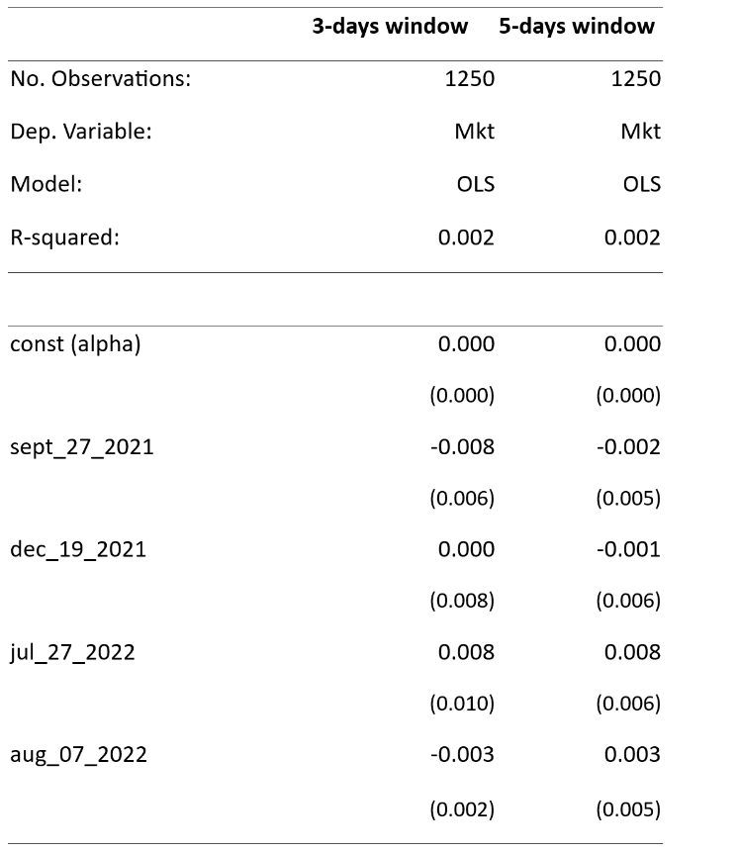

*sept 27 2021 corresponds to the original bill presentation, dec 19 2021 is the event window when Senator Manchin announced its opposition to the bill, jul 27 2022 corresponds to the agreement with Senator Manchin, and aug 07 2022 is the event window of the bill’s approval by Senate.

Source: Own elaboration with data from Fama & French (2023), and S&P Global (2024a).

In the next step, I estimate equation 2 using the OLS method to evaluate the presence of abnormal returns in the Energy sector in general, for that, I use the S&P500 Energy Index. Results presented in Tables 4 and 9 indicate that the Index experienced a significant and positive abnormal return of approximately 2.4% around the original bill presentation. This result is robust as seen in the estimation for a five-day window presented in Table 9 and Table 4A in Annex 1. Table 4 also shows a positive and significant (at 10% significance) coefficient for the final bill approval, however, as seen in Table 9 and Table 4A on Annex 1, this result does not hold with the robustness check. Graph 5 presents the scatter plot between the daily market returns and the S&P500 Energy Index daily returns.

However, the results indicate that the agreement with Senator Manchin generated significant abnormal returns of 1.9% with a significance level of 0.1. This result validates the hypothesis that the announcement of the agreement provided new information to the market, generating abnormal returns to the clean energy sector. Graph 6 presents the scatter plot between the daily market returns and the Wilder Hill Clean Energy Index daily returns.

**Table 4: OLS estimation of equation 2 with 3-day window for daily S&P500 Energy Index abnormal returns between January first 2018 and December 30 2022**

*sept 24 to sept 28 2021 corresponds to the original bill presentation, dec 17 to dec 21 2021 is the event window when Senator Manchin announced its opposition to the bill, jul 26 to jul 28 2022 corresponds to the agreement with Senator Manchin, and aug 05 to aug 09 2022 is the event window of the bill’s approval by Senate.  
Source: Own elaboration with data from Fama & French (2023), and S&P Global (2024b).

**Graph 5: Scatter plot between daily Market returns and the S&P500 Energy Index daily returns**

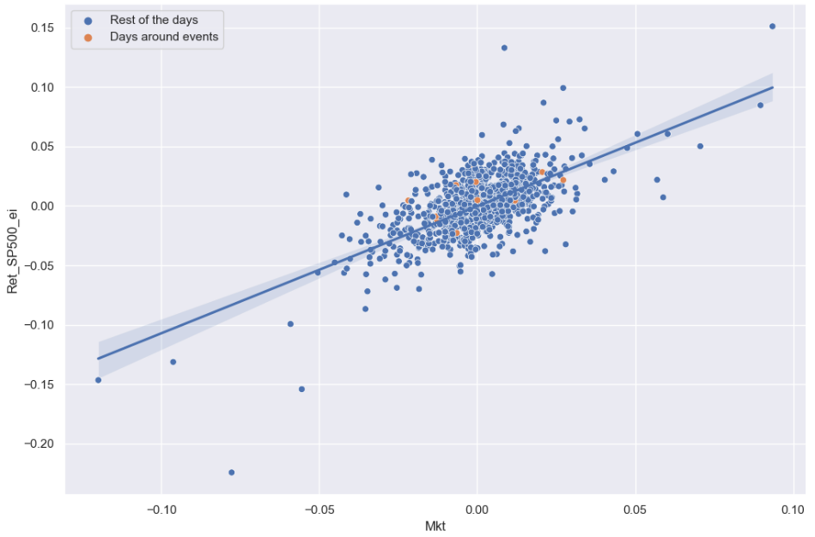  
Source: Own elaboration with data from Fama & French (2023), and S&P Global (2024b)

To understand how the bill impacted the renewable energy sector specifically, I use the NASDAQ Clean Energy Edge Index. Table 5 shows the results of the estimations. The dummy corresponding to the agreement with Senator Manchin has a significant and positive coefficient indicating that the announcement was followed by positive abnormal returns of approximately 1.91% on the renewable energy sector. This is consistent with the original hypothesis that the announcement provided new information to markets. The other three coefficients are not significant. As presented in Tables 9 and 5A, these results are robust to the 5-day window robustness check. Graph 6 presents the scatter plot between the NASDAQ Clean Energy Edge Index and the market returns.

**Table 5: OLS estimation of equation 2 with 3-day window for daily NASDAQ Clean Energy Edge Index abnormal returns between January first 2018 and December 30 2022**

*sept 24 to sept 28 2021 corresponds to the original bill presentation, dec 17 to dec 21 2021 is the event window when Senator Manchin announced its opposition to the bill, jul 26 to jul 28 2022 corresponds to the agreement with Senator Manchin, and aug 05 to aug 09 2022 is the event window of the bill’s approval by Senate.

Source: Own elaboration with data from Fama & French (2023), and NASDAQ (2024).

**Graph 6: Scatter plot between daily Market returns and the NASDAQ Clean Energy Edge Index daily returns**

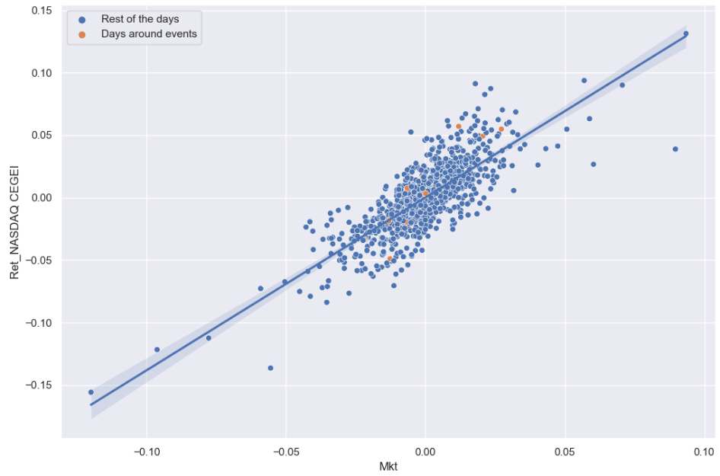  
Source: Own elaboration with data from Fama & French (2023), and NASDAQ (2024)

According to the findings of Bessec and Fouqau (2024) and Ardia et al.(2022), polluting or “brown companies” shares tend to be more sensitive to news and information related to the environment. To evaluate if this is the case also for the IRA’s approval, I evaluate the impact of the events on the Dow Jones U.S. Oil & Gas Index. Results are presented in Table 6. Surprisingly the oil and gas industries experienced positive abnormal returns of 2.3% during the announcement of the original bill. This result is robust to the 5-day window check (See Tables 9 and 6A).

One possible explanation for this unexpected finding is the presence of a carbon removal tax break in the bill, which might have been interpreted by the market as an opportunity for oil and gas companies to compensate for their CO2 emissions without affecting their core business. Another possibility is simply that the market expected tougher measures against the gas and oil industries, and that the actual content of the bill was softer than expected. In any case, it is important to remark that the content of the bill originally presented experienced important changes before the final approval. Graph 7 presents the scatter plot between market returns and the Dow Jones U.S. Oil & Gas Index.

Table 6 also reveals the existence of a positive abnormal return of 1.72% arownd the final bill approval for the Dow Jones U.S. Oil & Gas Index. However, as seen in tables 9 and 6A, this result is not robust to the 5-days window check.

**Table 6: OLS estimation of equation 2 with 3-day window for daily Dow Jones U.S. Oil & Gas Index abnormal returns between January first 2018 and December 30 2022**

*sept 24 to sept 28 2021 corresponds to the original bill presentation, dec 17 to dec 21 2021 is the event window when Senator Manchin announced its opposition to the bill, jul 26 to jul 28 2022 corresponds to the agreement with Senator Manchin, and aug 05 to aug 09 2022 is the event window of the bill’s approval by Senate.

Source: Own elaboration with data from Fama & French (2023), and S&P Global (2024c).

**Graph 7: Scatter plot between daily Market returns and the Dow Jones U.S. Oil & Gas Index daily returns**

Source: Own elaboration with data from Fama & French (2023), and S&P Global. (2024c)

In the case of the automotive industry represented by the S&P 500 Automobiles Industry Group Index, the results of the estimation of equation 2 are presented in Table 7. The dummy for the presentation of the bill has a significant and positive coefficient indicating abnormal returns of 2.1% approximately. This result is significant on the 5-day window robustness check as seen in Tables 9 and 7A. Therefore it is possible to conclude that the original bill presentation impacted positively the returns of the automobile industry. Graph 8 shows the scatter plot between the S&P 500 Automobiles Industry Group index returns and market returns.

**Table 7: OLS estimation of equation 2 with 3-day window for daily S&P 500 Automobiles Industry Index abnormal returns between January first 2018 and December 30 2022**

*sept 24 to sept 28 2021 corresponds to the original bill presentation, dec 17 to dec 21 2021 is the event window when Senator Manchin announced its opposition to the bill, jul 26 to jul 28 2022 corresponds to the agreement with Senator Manchin, and aug 05 to aug 09 2022 is the event window of the bill’s approval by Senate.

Source: Own elaboration with data from Fama & French (2023), and SP500-251020, (2023)

**Graph 8: Scatter plot between daily Market returns and the S&P 500 Automobiles Industry Group Index daily returns**

Source: Own elaboration with data from Fama & French (2023) and SP500-251020, (2023)

Arguably, the impact of the IRA on the automotive industry as a whole might be mixed, with leading companies in the electric vehicle space benefiting and the companies that depend on combustion models experiencing a negative impact. To understand the impact specifically in the electric vehicle segment, I evaluate the S&P Kensho Electric Vehicles Index which contains 44 U.S.-listed companies directly linked to the production of electric vehicles and their infrastructure. Results of the estimations for the S&P Kensho Electric Vehicles Index are presented in Table 8. Results do not indicate evidence of significant abnormal returns around the events. These results hold on the robustness check presented in Tables 9 and 8A.

**Table 8: OLS estimation of equation 2 with 3-day window for daily S&P Kensho Electric Vehicles Index abnormal returns between January first 2018 and December 30 2022**

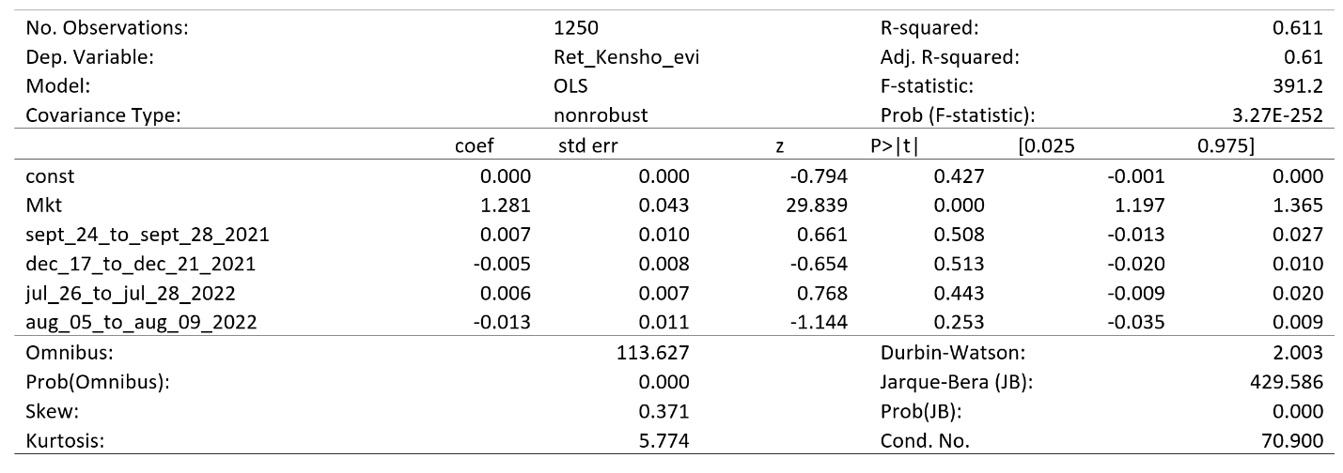 *sept 24 to sept 28 2021 corresponds to the original bill presentation, dec 17 to dec 21 2021 is the event window when Senator Manchin announced its opposition to the bill, jul 26 to jul 28 2022 corresponds to the agreement with Senator Manchin, and aug 05 to aug 09 2022 is the event window of the bill’s approval by Senate.

Source: Own elaboration with data from Fama & French (2023), and S&P Global (2024a).

**Graph 9: Scatter plot between daily Market returns and the S&P Kensho Electric Vehicles Index daily returns**

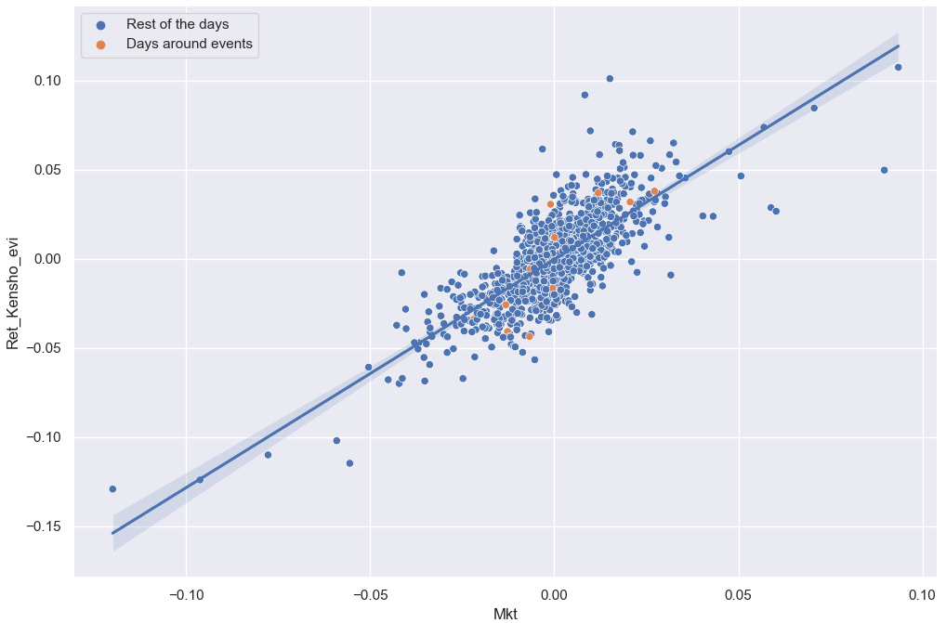

Source: Own elaboration with data from Fama & French (2023)and and S&P Global (2024a)

Finally, a summary of all the regressions and their corresponding robustness checks is is presented in table 9

**Table 9: Summary results of equation 2 with three-days and five-days windows for all the analyzed indexes**

*sept 27 2021 corresponds to the original bill presentation, dec 19 2021 is the event window when Senator Manchin announced its opposition to the bill, jul 27 2022 corresponds to the agreement with Senator Manchin, and aug 07 2022 is the event window of the bill’s approval by Senate.

Source: Own elaboration with data from Fama & French (2023), and S&P Global (2024a)

**6 Conclusions**

The Inflation Reduction Act represents one of the major policy decisions in the last decades to address climate change and reduce greenhouse emissions. It has an estimated total investment of $384.9 billion (Huntley Ricco and Arnon 2022) during the next 10 years, mainly on renewable energies and electric vehicles. The present article applied the event study methodology to analyze the impact of the bill on the US stock market specifically on the energy sector and in the automotive industry.

By analyzing the abnormal returns of the market in general, the present study concludes that the United States stock market as a whole did not experience abnormal returns during the main events related to the bill’s approval. Regarding the energy industry, the S&P500 Energy Index experienced a positive abnormal return of approximately 2.4% around the original bill presentation, while it did not experienced abnormal returns around the other key dates.

Additionally, the NASDAQ Clean Energy Edge Index that measures the performance of companies in the renewable energy segment experienced positive and significant abnormal returns of approximately 1.91% around the agreement with Senator Manchin. This confirms the original hypothesis that the announcement of the agreement provided valuable information to markets.

Surprisingly the Dow Jones U.S. Oil & Gas Index experienced positive abnormal returns of 2.3% during the presentation of the original bill, the Build Back Better Act.

In the case of the automobiles industry, the study found a positive abnormal return of 2.12% around the presentation of the original bill. Despite the bill’s incentives for the production and adoption of electric vehicles in the United Sates, the electric vehicle segment did not experience abnormal returns around key dates of the approval process.

**7 References**

Afik, Z., & Zabolotnyuk, Y. (2023). Information effect of credit rating announcements in transition economies. *Journal of International Financial Markets, Institutions and Money* , 89, 101878. https://doi.org/10.1016/j.intfin.2023.101878.

Ali, A., & Kallapur, S. (2001). Securities price consequences of the private securities litigation reform act of 1995 and related events. *The Accounting Review*, 76(3), 431–460. <http://www.jstor.org/stable/3068943>.

Ardia, D., Bluteau, K., Boudt, K., & Inghelbrecht, K. (2023). Climate change concerns and the performance of green vs. brown stocks. *Management Science*, 69(12), 7607-7632.

Badlam J. et al. (2022). The Inflation Reduction Act: Here’s what’s in it. McKinsey & Company. https://www.mckinsey.com/industries/public-sector/our-insights/the-inflation-reduction-act-heres-whats-in-it#/.

Bessec, M., & Fouquau, J. (2024). A green wave in media, a change of tack in stock markets. *Oxford Bulletin of Economics and Statistics*. Available at: https://doi.org/10.1111/obes.12597

Bhattacharya, U., Daouk, H., Jorgenson, B. & Kehr, C.H. (2000). When an event is not an event: the curious case of an emerging market. *Journal of Financial Economics*, 55 (1), 69–101.

Binder, J. (1998). The Event Study Methodology Since 1969. *Review of Quantitative Finance and Accounting*, 11, 111–137.

Boehmer, E., Masumeci, J., & Poulsen, A.B. (1991). Event study methodology under conditions of event-induced variance. *Journal of Financial Economics*, 30 253–272.

Brown, S. & Warner, J. (1980). Measuring security price performance*. Journal of Financial Economics*, 8, 205-258.

Brown, S. J., & Warner, J. B. (1985). Using daily stock returns: The case of event studies. *Journal of Financial Economics*, 14(1) 3-31. https://doi.org/10.1016/0304-405X(85)90042-X.

Dyckman, T., Philbrick, D., & Stephan, J. (1984). A Comparison of Event Study Methodologies Using Daily Stock Returns: A Simulation Approach. *Journal of Accounting Research*, 22, 1–30. https://doi.org/10.2307/2490855.

Fama, E., Fisher L., Jensen M., & Roll R.(1969). The adjustment of stock prices to new information. *International Economic Review,* 10,1-21.

Fama, E. (1991). Efficient capital markets: II. *Journal of Finance*, 46, 1575-1617.

Fama, E., & French, K. (2023). Production of U.S. Rm-Rf, SMB, and HML in the Fama-French Data Library. Chicago Booth Research Paper No. 23-22, Fama-Miller Working Paper, Available at SSRN: https://ssrn.com/abstract=4629613.

Fama, E. & French, K. (2024). Fama-French data library [Data set]. Dartmouth Colleger. Obtained on January 10, 2024. https://mba.tuck.dartmouth.edu/pages/faculty/ken.french/data_library.html.

Ferrer, R., Shahzad, S., López, R., & Jareño, F. (2018). Time and frequency dynamics of connectedness between renewable energy stocks and crude oil prices. *Energy Economics*, 76, 1-20. https://doi.org/10.1016/j.eneco.2018.09.022.

Garewal, R. (2021). Airlines Stock Market Response to Stimulus Bill Expectation On March 25th, 2020 An Event Study. Available at SSRN: https://ssrn.com/abstract=3760118.

Goh, J.C., & Ederington, L.H. (1999). Cross‐sectional variation in the stock market reaction to bond rating changes. *The Quarterly Review of Economics and Finance*, 39, 101–112.

Hooper, V., Timothy, H. & Kim, S. (2008). Sovereign Rating Changes – Do they Provide New Information to Stock Markets. *Economic Systems*, 32 (2), 142–166.

Huntley, J., Ricco, J. & Arnon, A. (2022). Senate-Passed Inflation Reduction Act: Estimates of Budgetary and Macroeconomic Effects. University of Pennsylvania, Penn-Wharton Budget Model. https://budgetmodel.wharton.upenn.edu/issues/2022/8/12/senate-passed-inflation-reduction-act.

Iza & Haji Y. (1978). An Empirical Analysis of the Economic Effects of Mandatory Government Audit Requirements. Ph.D. dissertation, University of Chicago.

Johnson, M., Kasznik, R., & Nelson K. (2000). Shareholder wealth effects of the private securities litigation reform act of 1995. *Review of Accounting Studies*, 513, 217–233.

Jenkins, J.D., Mayfield, E.N., Farbes, J., Jones, R., Patankar, N., Xu, Q., & Schivley, G. (2022). Preliminary Report: The Climate and Energy Impacts of the Inflation Reduction Act of 2022. REPEAT Project, Princeton, NJ. https://repeatproject.org/docs/REPEAT_IRA_Prelminary_Report_2022-08-04.pdf..

Kliger, D., & Sarig, O. (2000). The information value of bond ratings. *The Journal of Finance*, 55 (6), 2879-2902.

Khotari, S.P., & Warner J.B (2006). Econometrics of Event Studies. Center for Corporate Governance, Tuck School of Business at Dartmouth.

Lobão, J., Pacheco, L., & Campos, S. (2019). Stock price effects of bank rating announcements: An application to European Union countries. *International Journal of Finance & Economics*, 24(1), 4–19. https://doi.org/10.1002/ijfe.1645.

MacKinlay, A.C. (1997). Event Studies in Economics and Finance. *Journal of Economic Literature*, 35 (1), 13–39.

NASDAQ. (2024). CELS: NASDAQ Clean Edge Green Energy (CELS), index quote. NASDAQ. Obtained on March 19, 2024 from: https://indexes.nasdaqomx.com/Index/History/CELS.

Pandey, D.K., & Kumari, V. (2020). Event study on the reaction of the developed and emerging stock markets to the 2019-nCoV outbreak. *International Review of Economics & Finance*, 71, 467-483. https://doi.org/10.1016/j.iref.2020.09.014.

Rezaee, Z., & Pankaj J.K. (2005). The Sarbanes-Oxley Act of 2002 and Security Market Behavior: Early Evidence. *Contemporary accounting research*, 23(3), 629-654.

Richards, A., & Deddouche, D. (2003). Bank rating changes and bank stock returns—Puzzling evidence from the emerging markets. *Journal of Emerging Market Finance*, 2, 337–363.

Reboredo, J. C. (2015). Is there dependence and systemic risk between oil and renewable energy stock prices? *Energy Economics*, 48, 32-45. https://doi.org/10.1016/j.eneco.2014.12.009.

Reboredo, J.C., Rivera-Castro, M.A., & Ugolini, A. (2016). Wavelet-based test of co-movement and causality between oil and renewable energy stock prices. *Energy Economics*, 61, 241-252. https://www.sciencedirect.com/science/article/pii/S0140988316302961?via%3Dihub.

Song, Y., Ji, Q., Du, Y., & Geng, J. (2019). The dynamic dependence of fossil energy, investor sentiment and renewable energy stock markets. *Energy Economics*, 84, 104564.

S&P Global. (2024a). KEVP: S&P Kensho Electric Vehicles Index (KEVP), index quote. S&P Global. Obtained on March 19, 2024 from: <https://www.spglobal.com/spdji/en/indices/equity/sp-kensho-electric-vehicles-index/#overview>.

S&P Global. (2024b). SPN: S&P 500 Energy Index (SPN), index quote. S&P Global. Obtained on March 19, 2024 from: <https://www.spglobal.com/spdji/en/indices/equity/sp-500-energy-sector/#overview>.

S&P Global. (2024c). DJUSEN: Dow Jones U.S. Oil & Gas Index (DJUSEN), index quote. S&P Global. Obtained on March 19, 2024 from: https://www.spglobal.com/spdji/en/indices/equity/dow-jones-us-oil-gas-index/ #overview.

SP500-251020. (2023). S&P 500 Automobiles Industry index, stock quote. Yahoo Finance. Obtained on December 17, 2023. https://finance.yahoo.com/quote/%5ESP500-251020/.

The White House (2023). Building a Clean Energy Economy: A Guidebook To The Inflation Reduction Act’s Investments in Clean Energy And Climate Action. https://www.whitehouse.gov/wp-content/uploads/2022/12/Inflation-Reduction-Act-Guidebook.pdf.

**ANNEX I:**

**Table 5. Regression result for specification 1 of Equation 1**

|  |  |  |  |  |  |  |
| --- | --- | --- | --- | --- | --- | --- |
| Dep. Variable: | | Similarity |  | R-squared: | | 0.088 |
| Model: | | OLS |  | Adj. R-squared: | | 0.077 |
| Method: | | Least Squares |  | F-statistic: | | 8.119 |
| No. Observations: | | 256 |  | Prob (F-statistic): | | 3.50E-05 |
| Df Residuals: | | 252 |  | Log-Likelihood: | | -253.68 |
| Df Model: | | 3 |  | AIC: | | 515.4 |
| Covariance Type: | | nonrobust |  | BIC: |  | 529.5 |
|  | coef | std err | t | P>|t| | [0.025 | 0.975] |
| const | -1.1466 | 0.073 | -15.797 | 0 | -1.29 | -1.004 |
| output_gap_quart | 3.3271 | 2.404 | 1.384 | 0.168 | -1.407 | 8.062 |
| Inflation | -14.281 | 2.914 | -4.9 | 0 | -20.02 | -8.541 |
| Delta MRO | 0.7098 | 0.279 | 2.543 | 0.012 | 0.16 | 1.259 |
| Omnibus: | | 92.154 |  | Durbin-Watson: | | 0.537 |
| Prob(Omnibus): | | 0 |  | Jarque-Bera (JB): | | 287.687 |
| Skew: | | -1.566 |  | Prob(JB): | | 3.38E-63 |
| Kurtosis: | | 7.143 |  | Cond. No. | | 76.3 |

Source: Own elaboration.

**Table 6. Regression result for specification 2 of Equation 1**

|  |  |  |  |  |  |  |
| --- | --- | --- | --- | --- | --- | --- |
| Dep. Variable: | | Similarity | | R-squared: | | 0.402 |
| Model: | | OLS |  | Adj. R-squared: | | 0.352 |
| Method: | | Least Squares |  | F-statistic: | | 0.349 |
| No. Observations: | | 256 |  | Prob (F-statistic): | | 1.38E+02 |
| Df Residuals: | | 254 |  | Log-Likelihood: | | 1.05E-25 |
| Df Model: | | 1 |  | AIC: | | -210.02 |
| Covariance Type: | | nonrobust |  | BIC: | | 424 |
|  | coef | std err | t | P>|t| | [0.025 | 431.1 |
| const | -2.1095 | 0.067 | -31.627 | 0 | -2.241 | -1.978 |
| Time | 2.00E-04 | 1.37E-05 | 11.738 | 0 | 0.00E+00 | 0.00E+00 |
| Omnibus: | | 177.648 |  | Durbin-Watson: | | 0.679 |
| Prob(Omnibus): | | 0 |  | Jarque-Bera (JB): | | 2199.754 |
| Skew: | | -2.619 |  | Prob(JB): | | 0 |
| Kurtosis: | | 16.372 |  | Cond. No. | | 9.44E+03 |

Source: Own elaboration.

**Table 7. Regression result for specification 3 of Equation 1**

|  |  |  |  |  |  |  |
| --- | --- | --- | --- | --- | --- | --- |
| Dep. Variable: | | Similarity |  | R-squared: | | 0.494 |
| Model: | | OLS |  | Adj. R-squared: | | 0.485 |
| Method: | | Least Squares |  | F-statistic: | | 61.15 |
| No. Observations: | | 256 |  | Prob (F-statistic): | | 5.21E-36 |
| Df Residuals: | | 251 |  | Log-Likelihood: | | -178.4 |
| Df Model: | | 4 |  | AIC: | | 366.8 |
| Covariance Type: | | nonrobust |  | BIC: | | 384.5 |
|  | coef | std err | t | P>|t| | [0.025 | 0.975] |
| const | -1.8147 | 0.072 | -25.265 | 0 | -1.956 | -1.673 |
| Time | 2.00E-04 | 1.25E-05 | 14.175 | 0 | 0.00E+00 | 0.00E+00 |
| output_gap_quart | 6.4006 | 1.808 | 3.54 | 0 | 2.839 | 9.962 |
| Inflation | -17.7613 | 2.19 | -8.11 | 0 | -22.074 | -13.448 |
| Delta MRO | 0.2619 | 0.211 | 1.242 | 0.215 | -0.153 | 0.677 |
| Omnibus: | | 209.319 |  | Durbin-Watson: | | 0.929 |
| Prob(Omnibus): | | 0 |  | Jarque-Bera (JB): | | 4252.609 |
| Skew: | | -3.089 |  | Prob(JB): | | 0.00E+00 |
| Kurtosis: | | 21.987 |  | Cond. No. | | 3.76E+05 |

Source: Own elaboration.

**Table 8. Regression result for specification 4 of Equation 1**

|  |  |  |  |  |  |  |
| --- | --- | --- | --- | --- | --- | --- |
| Dep. Variable: | Similarity | |  | R-squared: | | 0.509 |
| Model: | | OLS |  | Adj. R-squared: | | 0.501 |
| Method: | | Least Squares |  | F-statistic: | | 65.11 |
| No. Observations: | | 256 |  | Prob (F-statistic): | | 1.04E-37 |
| Df Residuals: | | 251 |  | Log-Likelihood: | | -174.38 |
| Df Model: | | 4 |  | AIC: | | 358.8 |
| Covariance Type: | | nonrobust |  | BIC: | | 376.5 |
|  | coef | std err | t | P>|t| | [0.025 | 0.975] |
| const | -1.8776 | 0.073 | -25.723 | 0 | -2.021 | -1.734 |
| Time count | 0.0061 | 0.00E+00 | 14.675 | 0 | 0.005 | 0.007 |
| output_gap_quart | 6.1769 | 1.778 | 3.474 | 0.001 | 2.676 | 9.678 |
| Inflation | -16.6609 | 2.148 | -7.755 | 0 | -20.892 | -12.43 |
| Delta MRO | 0.2722 | 0.207 | 1.313 | 0.19 | -0.136 | 0.68 |
| Omnibus: | | 222.646 |  | Durbin-Watson: | | 0.955 |
| Prob(Omnibus): | | 0 |  | Jarque-Bera (JB): | | 5311.103 |
| Skew: | | -3.326 |  | Prob(JB): | | 0.00E+00 |
| Kurtosis: | | 24.3 |  | Cond. No. | | 1.13E+04 |

Source: Own elaboration.

**ANNEX II:**

**Table 9. Regression result for specification 1 of equation 2**

|  |  |  |  |  |  |  |
| --- | --- | --- | --- | --- | --- | --- |
| Dep. Variable: | | AV_cum_ab_returns | | R-squared: | | 0.028 |
| Model: | | OLS | | Adj. R-squared: | | 0.025 |
| Method: | | Least Squares | | F-statistic: | | 7.43 |
| No. Observations: | | 256 |  | Prob (F-statistic): | | 0.00686 |
| Df Residuals: | | 254 |  | Log-Likelihood: | | 512.94 |
| Df Model: | | 1 |  | AIC: | | -1022 |
| Covariance Type: | | nonrobust | | BIC: | | -1015 |
|  | coef | std err | t | P>|t| | [0.025 | 0.975] |
| const | 0.0318 | 0.002 | 15.532 | 0 | 0.028 | 0.036 |
| Pessimism | 0.6962 | 0.255 | 2.726 | 0.007 | 0.193 | 1.199 |
| Omnibus: | | 257.832 |  | Durbin-Watson: | | 1.945 |
| Prob(Omnibus): | | 0 |  | Jarque-Bera (JB): | | 9318.849 |
| Skew: | | 4.005 |  | Prob(JB): | | 0 |
| Kurtosis: | | 31.451 |  | Cond. No. | | 125 |

Source: Own elaboration.

**Table 10. Regression result for specification 2 of equation 2**

|  |  |  |  |  |  |  |
| --- | --- | --- | --- | --- | --- | --- |
| Dep. Variable: | | AV_cum_ab_returns | | R-squared: | | 0.029 |
| Model: | | OLS | | Adj. R-squared: | | 0.017 |
| Method: | | Least Squares | | F-statistic: | | 2.505 |
| No. Observations: | | 256 |  | 24 Feb 2024 | | 0.0597 |
| Df Residuals: | | 252 |  | Log-Likelihood: | | 513.01 |
| Df Model: | | 3 |  | AIC: | | -1018 |
| Covariance Type: | nonrobust |  | | BIC: | | -1004 |
|  | coef | std err | t | P>|t| | [0.025 | 0.975] |
| const | 0.0283 | 0.004 | 7.802 | 0 | 0.021 | 0.035 |
| output_gap_quart | -0.1648 | 0.12 | -1.37 | 0.172 | -0.402 | 0.072 |
| Inflation | 0.1707 | 0.146 | 1.17 | 0.243 | -0.117 | 0.458 |
| Delta MRO | -0.0326 | 0.014 | -2.334 | 0.02 | -0.06 | -0.005 |
| Omnibus: | | 269.377 |  | Durbin-Watson: | | 1.993 |
| Prob(Omnibus): | | 0 |  | Jarque-Bera (JB): | | 11479.61 |
| Skew: | | 4.231 |  | Prob(JB): | | 0 |
| Kurtosis: | | 34.695 |  | Cond. No. | | 76.3 |

Source: Own elaboration.

**Table 11. Regression result for specification 3 of equation 2**

|  |  |  |  |  |  |  |
| --- | --- | --- | --- | --- | --- | --- |
| Dep. Variable: | | AV_cum_ab_returns | | R-squared: | | 0.024 |
| Model: | | OLS | | Adj. R-squared: | | 0.02 |
| Method: | | Least Squares | | F-statistic: | | 6.301 |
| No. Observations: | | 256 |  | Prob (F-statistic): | | 0.0127 |
| Df Residuals: | | 254 |  | Log-Likelihood: | | 512.39 |
| Df Model: | | 1 |  | AIC: | | -1021 |
| Covariance Type: | | nonrobust | | BIC: | | -1014 |
|  | coef | std err | t | P>|t| | [0.025 | 0.975] |
| const | 0.0319 | 0.002 | 15.53 | 0 | 0.028 | 0.036 |
| Pessimism x similarity | -0.405 | 0.161 | -2.51 | 0.013 | -0.723 | -0.087 |
| Omnibus: | | 257.477 |  | Durbin-Watson: | | 1.939 |
| Prob(Omnibus): | | 0 |  | Jarque-Bera (JB): | | 9246.391 |
| Skew: | | 3.999 |  | Prob(JB): | | 0 |
| Kurtosis: | | 31.335 |  | Cond. No. | | 78.6 |

Source: Own elaboration.

**Table 12. Regression result for specification 4 of Equation 2**

|  |  |  |  |  |  |  |
| --- | --- | --- | --- | --- | --- | --- |
| Dep. Variable: | AV_cum_ab_returns | |  | R-squared: | | 0.041 |
| Model: | | OLS |  | Adj. R-squared: | | 0.026 |
| Method: | | Least Squares |  | F-statistic: | | 2.704 |
| No. Observations: | | 256 |  | Prob (F-statistic): | | 0.031 |
| Df Residuals: | | 251 |  | Log-Likelihood: | | 514.65 |
| Df Model: | | 4 |  | AIC: | | -1019 |
| Covariance Type: | | nonrobust |  | BIC: | | -1002 |
|  | coef | std err | t | P>|t| | [0.025 | 0.975] |
| const | 0.031 | 0.004 | 7.93 | 0 | 0.023 | 0.039 |
| Pessimism x similarity | -0.3263 | 0.181 | -1.798 | 0.073 | -0.684 | 0.031 |
| output_gap_quart | -0.0963 | 0.126 | -0.766 | 0.444 | -0.344 | 0.151 |
| Inflation | 0.0471 | 0.161 | 0.293 | 0.77 | -0.269 | 0.363 |
| Delta MRO | -0.0254 | 0.014 | -1.753 | 0.081 | -0.054 | 0.003 |
| Omnibus: | | 260.692 |  | Durbin-Watson: | | 1.997 |
| Prob(Omnibus): | | 0 |  | Jarque-Bera (JB): | | 9970.554 |
| Skew: | | 4.052 |  | Prob(JB): | | 0 |
| Kurtosis: | | 32.48 |  | Cond. No. | | 105 |

Source: Own elaboration.

1. The whole code with the estimations can be accessed at: https://github.com/CamSalda/Inflation-Reduction-Act-event-study/blob/main/Event%20study%20code_02-25-2024.ipynb
2. Msc. in Economics and Msc. in Financial Economics from the École d'Économie de la Sorbonne, Université Paris 1 Panthéon-Sorbonne. E-mail: jcamsalda@gmail.com